
Memo
Date: January 23, 2023
To: SoftPro FNF Michigan Agents
CC: Stan Hunter, Meredith Weingarden, Kelley Shellhaas, Alyssa Allen
From: FNF Michigan Agency
RE: Updating SoftPro Lookup Table for 2021 ALTA Forms
It has recently come to our attention that SoftPro software users need to update their “Policy Lookup Code Table,” by adding the entries of the name of the policy(ies) you want to use for the ALTA 2021 Owner and Loan Policy versions, adding the form effective date of 7/1/2021. Below are the instructions for both SoftPro Select and SoftPro Standard or Enterprise. Please be sure you are following the instructions for your specific version noted below:

SoftPro Standard &r Enterprise directions:

NOTE: You will need to do this for each policy type to be issued.

- On Policy Premium screen, click in field “Underwriter/Policy Look-up Code” Enter a short name (ie - LP2021 or OP2021 or HOP201)
- Click in next field “Underwriter/Policy Description” and give it a description/name (ie ALTA Loan Policy (2021))
- In the “New Policy Type” dropdown, choose the appropriate policy type
- Click back in the “Underwriter/Policy Look-up Code” field and press the F9 function key
- Click on "Insert Entry" to save to your look-up tables

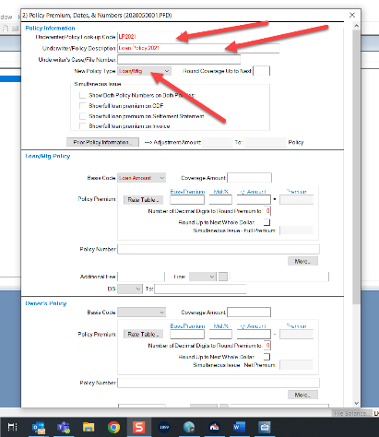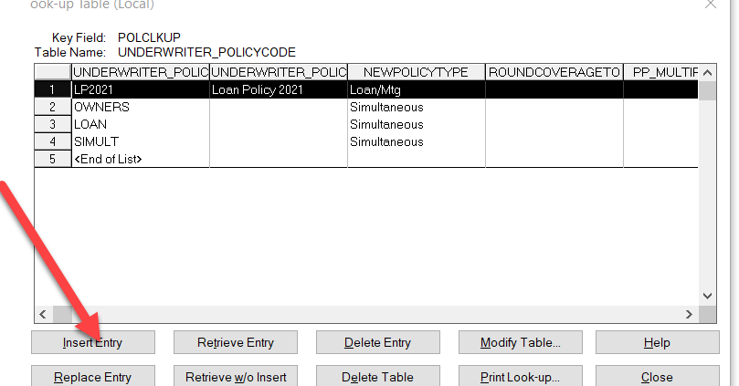

You may also press F1 to access Online Help.

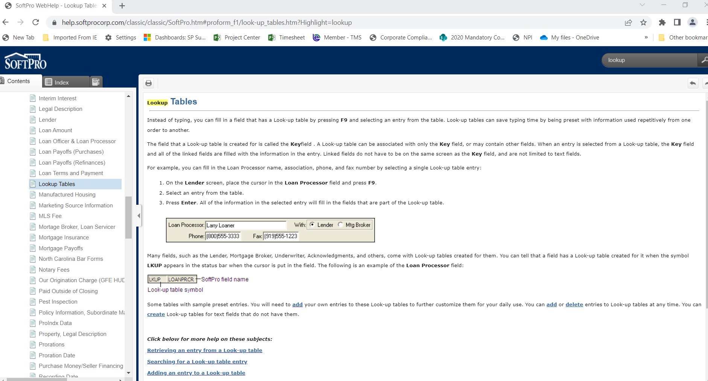

NOTE: This is not a document issue but a “Lookup Table” modification needed.

For your convenience, here are all of the viable 2021 ALTA policy descriptions:
ALTA Owner's Policy (2021)
ALTA Homeowner's Policy (2021)
ALTA Loan Policy (2021)
ALTA Expanded Coverage Residential Loan Policy - Assessments Priority (2021)
ALTA Expanded Coverage Residential Loan Policy Current - Assessments (2021)
ALTA Short Form Expanded Coverage Residential Loan Policy - Assessments Priority (2021)
ALTA Short Form Expanded Coverage Residential Loan Policy - Current Assessments (2021)
ALTA Short Form Residential Loan Policy - Assessments Priority (2021)
ALTA Short Form Residential Loan Policy - Current Assessments (2021)
ALTA Residential Limited Coverage Junior Loan Policy (2022)
ALTA Short Form Residential Limited Coverage Junior Loan Policy (2022)
Residential Limited Coverage Mortgage Modification Policy (2022)

