
Memo
Date: January 23, 2023
To: SoftPro FNF Michigan Agents
CC: Stan Hunter, Meredith Weingarden, Kelley Shellhaas, Alyssa Allen
From: FNF Michigan Agency
RE: Updating SoftPro Lookup Table for 2021 ALTA Forms
It has recently come to our attention that SoftPro software users need to update their “Policy Lookup Code Table,” by adding the entries of the name of the policy(ies) you want to use for the ALTA 2021 Owner and Loan Policy versions, adding the form effective date of 7/1/2021. Below are the instructions for both SoftPro Select and SoftPro Standard or Enterprise. Please be sure you are following the instructions for your specific version noted below:

SoftPro Select Directions

If you do not have the ability or permission to edit “Lookup Tables,” please contact SoftPro Support softprosupport@SoftProCorp.com and ask them to assist you with updating the entries in your “Lookup Table.” The update should take only a few minutes.

If you do have permission to access the “Lookup Table,” please follow the instructions noted below.

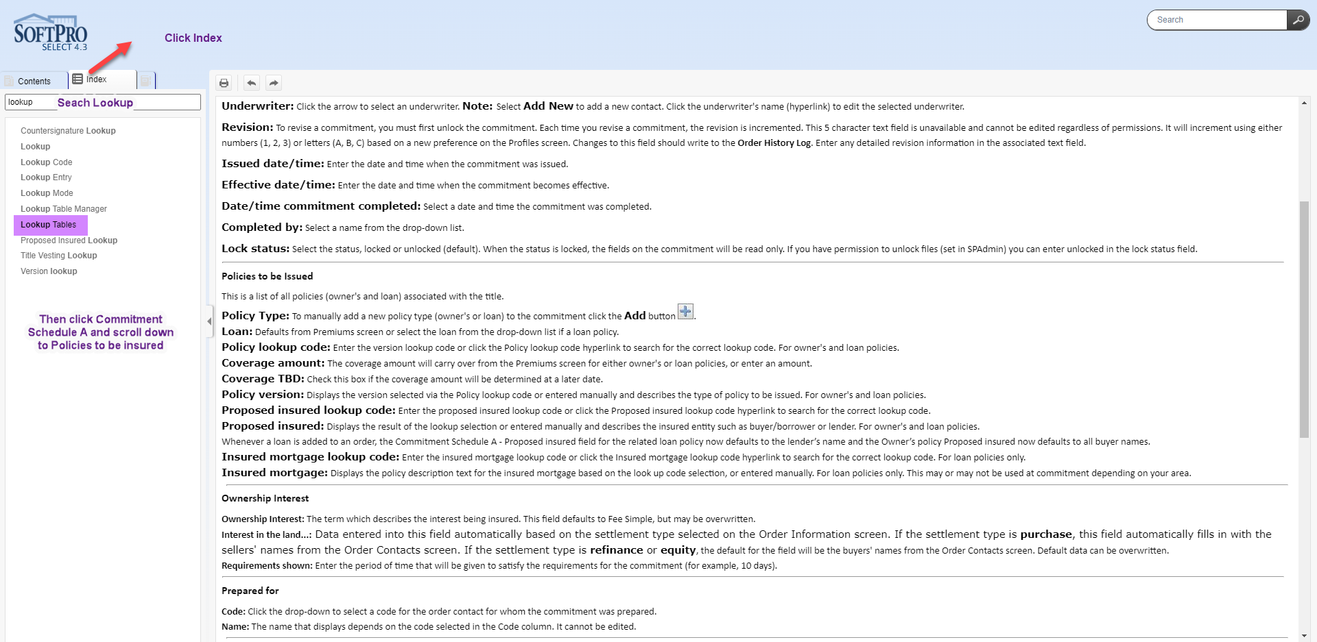

Added "Policies to be issued" to the commitment Schedule A Lookup Table (Loan and Owner's Policies versions)

NOTE: You will need to do this for each policy type to be issued.

- Make sure you highlight the correct "Policy Type" before you start step (2)
- Enter a short name (ie - LP2021 or OP2021 or HOP201)
- Enter the Title of the policy as you want it to appear on your Commitment (ie ALTA Loan Policy (2021))
- Click on "Policy Lookup Code" which will bring up the lookup table
- Click on "Insert entry"
- Click on "Save" (floppy disk icon)

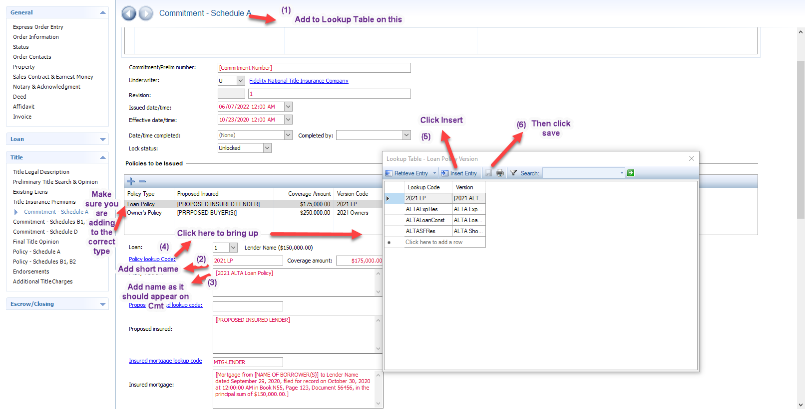

You can also click on the "?" at the very right of the screen in Select to get to help and videos.

NOTE: This is not a document issue but a “Lookup Table” issue

